CHAPTER THREE
SYSTEM ANALYSIS AND DESIGN

3.1 PROPOSED SYSTEM OVERVIEW
The system developed in this study was an AI-powered personalized learning assistant designed to support students with curriculum-grounded tutoring, material ingestion, and adaptive conversational assistance. The platform was implemented as a web-based tutoring environment in which authenticated users could upload course materials, build a personal knowledge base, interact with an AI tutor, and review their learning activity through a dashboard. The overall design responded to the long-standing Intelligent Tutoring System (ITS) principle that effective digital tutoring environments should combine a user interface, a domain knowledge source, tutoring logic, and a learner model into a coordinated structure (Alkhatlan and Kalita, 2018).
The proposed system was deliberately designed around controlled personalization rather than unrestricted open-domain generation. This design choice was informed by recent studies showing that personalized AI tutoring becomes more useful when responses are tied to contextual educational materials and pedagogical constraints rather than generic language generation alone (Wang et al., 2024; El Hajji et al., 2025). It was also guided by concerns in the literature that poorly bounded AI tutors may create misplaced trust, over-automation, or misleading confidence in learners if the system does not clearly communicate what it knows and what it does not know (Qadir and Mumtaz, 2025).
Accordingly, the implemented platform was structured around five core subsystems:

Table 3.1: Core subsystems of the proposed learning assistant
Subsystem | Main role in the system | Implemented elements
Authentication and access control | Protect user data and enforce private learning sessions | Better Auth, protected routes, session-aware middleware
Curriculum ingestion pipeline | Accept and process uploaded learning materials | PDF/TXT upload, text extraction, chunking, embedding generation
Knowledge retrieval layer | Retrieve relevant curriculum context for each user query | pgvector similarity search over document embeddings
Adaptive tutoring engine | Generate responses grounded in retrieved context and learner settings | OpenRouter-backed chat route, Socratic mode, strict curriculum mode, experience-based prompt adaptation
Learning management interface | Support interaction, document management, and activity review | Dashboard, library, analytics, chat interface, settings page

The system also reflected the educational motivation behind scalable AI tutoring. LearnLM Team (2025) reported that AI-supported tutoring can improve immediate student problem-solving outcomes under structured instructional conditions, while Wang et al. (2024) showed that human-AI tutoring support can strengthen guidance quality in real-time instructional settings. Based on these findings, the present study adopted a system architecture that emphasized guided tutoring, transparent curriculum grounding, and reusable learning records rather than a general-purpose chatbot.

3.2 SYSTEM ARCHITECTURE
The architecture of the proposed system followed a layered web application model implemented with Next.js App Router, TypeScript, Tailwind CSS, Neon PostgreSQL, Prisma ORM, Better Auth, OpenRouter, and the Vercel AI SDK. Figure 3.1 presents the high-level arrangement of the major components.

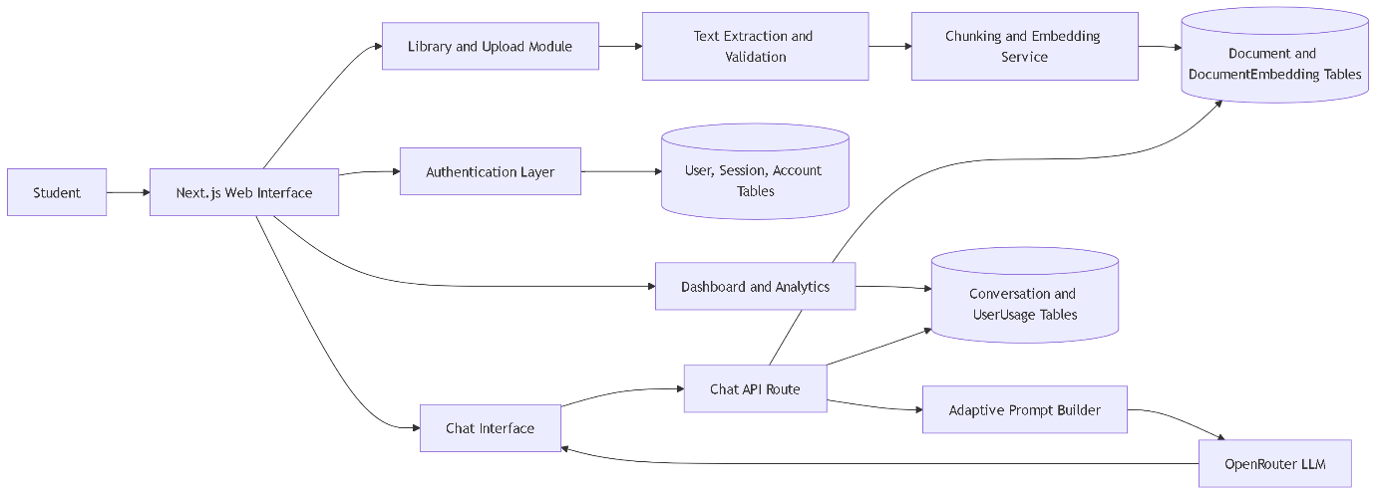
Figure 3.1: High-level architecture of the AI-powered personalized learning assistant

As shown in Figure 3.1, the frontend layer handled user interaction through route-based pages for login, dashboard access, document management, analytics, settings, and AI chat. The middleware layer enforced route protection by redirecting unauthenticated users away from protected learning pages. The application server layer hosted the upload action, the chat API route, and the supporting services for knowledge retrieval, usage tracking, and session handling. The data layer stored user records, documents, vector embeddings, conversations, and usage counters in PostgreSQL.
The architecture also adapted established ITS ideas into a modern LLM-based design. The interface model was implemented through the dashboard and chat screens, the domain model was represented by user-uploaded curriculum documents and their embeddings, the tutoring model was operationalized through the prompt rules and response settings, and the learner model was simplified into usage counts and stored preferences. This mapped classical ITS structure into a practical web deployment that could be implemented within the project scope (Alkhatlan and Kalita, 2018).
To reduce hallucination risk, the chat route retrieved relevant material before text generation and inserted the returned evidence directly into the system prompt. This design corresponded with the emphasis in recent educational AI systems on context-grounded tutoring and transparent instructional support (El Hajji et al., 2025). The architecture also required that retrieved context be scoped to the current authenticated user, thereby preventing document leakage between users and preserving data separation.

3.3 KNOWLEDGE INGESTION AND RETRIEVAL MODULE
The knowledge ingestion module was designed to transform raw curriculum materials into a searchable semantic knowledge base. Users submitted PDF or plain text files through the library interface. On the server side, each upload was first validated for type and file size, with a maximum file size of 10 MB. PDF content was parsed into raw text, while text files were ingested directly. The extracted text was then stored in the document table and passed to the vectorization pipeline.

The vectorization workflow is summarized in Figure 3.2.

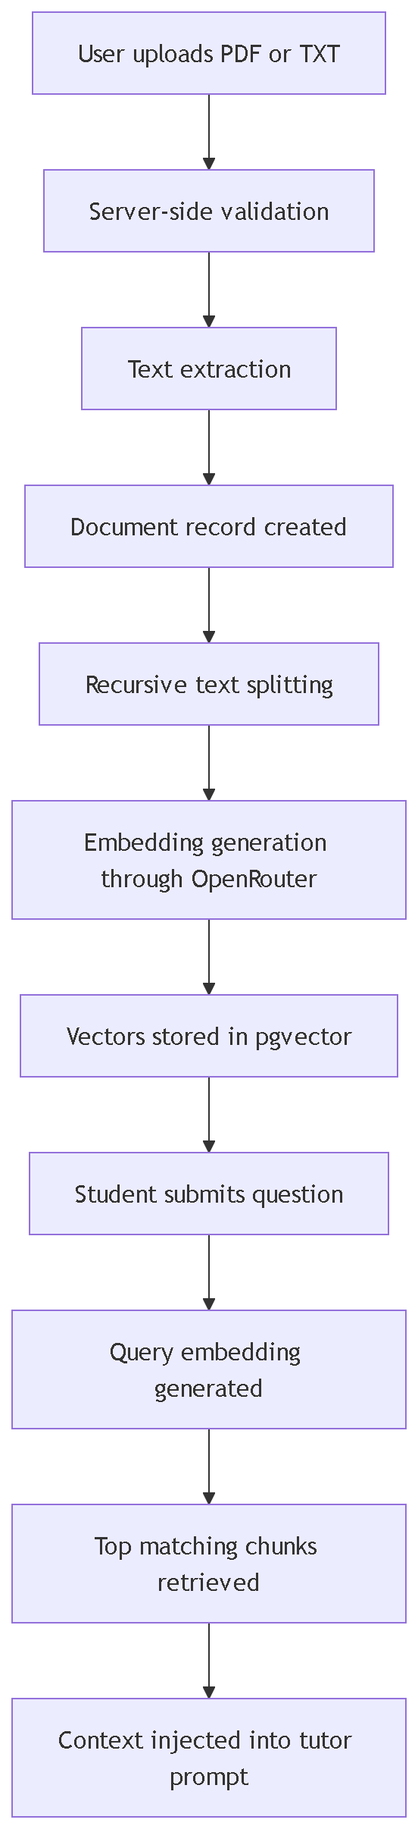
Figure 3.2: Curriculum ingestion and retrieval workflow

The chunking stage used recursive character splitting with a chunk size of 1000 characters and an overlap of 200 characters. This approach preserved continuity between adjacent segments and reduced the risk that conceptually related passages would be separated too aggressively. The design choice aligned with the requirement that educational support systems should retain sufficient explanatory context to support coherent tutoring rather than isolated sentence retrieval.
After chunking, embeddings were generated in batches using an OpenRouter-compatible embedding endpoint. Each vector was then inserted into PostgreSQL using raw SQL because the embedding column was defined as a `vector(2048)` type, which required explicit handling through pgvector. During query time, the system embedded the student's latest message, executed a nearest-neighbor search over the authenticated user's indexed materials, and returned the top five most relevant chunks. This allowed the system to ground responses in semantically related passages rather than keyword matches.
The design of this module was consistent with the view that AI tutoring systems should become more context-aware, flexible, and responsive to student materials rather than remain fixed, one-size-fits-all teaching tools (El Hajji et al., 2025). At the same time, the module remained intentionally scoped: it supported curriculum-grounded retrieval, but it did not yet include automated topic labeling, prerequisite graph modeling, or deep mastery inference.

3.4 ADAPTIVE TUTORING AND PERSONALIZATION MODULE
The tutoring module was built around a streaming chat endpoint connected to OpenRouter models through the Vercel AI SDK. Once the user submitted a message, the system first enforced API and token limits, then extracted the latest query, retrieved relevant context from the knowledge base, and constructed an adaptive system prompt. The prompt identified the tutor as "Lumina," instructed it to use clear tutorial formatting, and required a source placard at the end of each response. This explicit source signaling was included to help learners distinguish between curriculum-grounded answers and fallback general knowledge, which addressed trust-calibration concerns highlighted by Qadir and Mumtaz (2025).

Personalization in the current system was implemented through three practical mechanisms:

Table 3.2: Personalization mechanisms embedded in the tutoring engine
Personalization mechanism | Operational logic | Intended instructional effect
Socratic mode | Stored user preference determines whether the tutor guides through questions rather than only giving direct explanations | Encourage reflective learning and active reasoning
Strict curriculum mode | Stored user preference determines whether the model may rely only on uploaded materials or may supplement with general knowledge | Reduce hallucination and maintain instructional transparency
Experience-level adaptation | The tutor classified students as new, intermediate, or experienced using the number of prior API interactions | Adjust explanation depth, vocabulary, and level of scaffolding

This implementation reflected a lightweight learner model rather than a full cognitive tracing engine. The project requirements identified topic mastery tracking as future work, so the learner profile in the implemented version depended on usage activity and explicit preferences rather than a formal mastery score. Even so, the design still aligned with evidence that AI-supported tutoring becomes more effective when instructional behavior is adapted to the learner's needs and interaction context (LearnLM Team, 2025; Wang et al., 2024).
The tutoring logic also preserved conversation continuity by storing updated chat histories in the conversation table after successful responses. This allowed the chat interface to reopen the most recent learning session and present students with ongoing conversational context, which is important for individualized support. However, unlike more advanced experimental tutors, the current design did not yet incorporate persistent concept maps, assessment-driven remediation rules, or multimodal tutoring feedback.

3.5 USER INTERFACE DESIGN
The user interface was designed as a responsive academic workspace composed of five main pages: authentication, dashboard, library, analytics, chat, and settings. The visual structure emphasized clarity, low-friction navigation, and direct access to the system's primary learning tasks. In interface terms, the design attempted to balance the motivational value of modern conversational systems with the need for disciplined instructional structure.
The dashboard page acted as the learner's entry point by presenting a greeting, recent materials, indexed document count, and activity streak. The library page provided drag-and-drop and file-picker upload support, plus indexed document cards for retrieval management. The chat page delivered the main tutoring experience and included model selection, optional document scoping, suggested prompts, streaming responses, and markdown-based rendering. The analytics page summarized questions asked, total chat sessions, indexed materials, and a five-week activity distribution. Finally, the settings page allowed users to update their profile, toggle tutoring preferences, and remove stored learning data.
The interface design was informed by recent literature arguing that engagement with AI learning systems depends not only on the model's intelligence but also on the quality of the learner's interaction experience and the learner's ability to interpret the tool correctly (Qadir and Mumtaz, 2025). In practical terms, this led to three UI priorities:
1. Clear separation of learning tasks, so students could upload materials, chat, and review activity without confusion.
2. Visible instructional controls, so users could explicitly choose Socratic guidance and strict curriculum grounding.
3. Immediate contextual feedback, so uploads, indexing status, loading states, and error conditions remained understandable.
Overall, the proposed system design translated the research objective into a deployable educational web application. It combined curriculum ingestion, semantic retrieval, adaptive prompting, and learner-facing dashboards within a unified architecture. The next chapter presents how this design was implemented in code, what functional outputs were achieved, and what limitations remained at the implementation stage.

CHAPTER FOUR
SYSTEM IMPLEMENTATION AND DISCUSSION

4.1 IMPLEMENTATION DETAILS
The proposed personalized learning assistant was implemented as a full-stack web application using Next.js 16 with the App Router architecture, TypeScript, React 19, Tailwind CSS, Prisma ORM, Neon PostgreSQL, Better Auth, OpenRouter, and the Vercel AI SDK. The implementation translated the design presented in Chapter Three into an operational tutoring platform that could authenticate users, ingest curriculum materials, retrieve semantically relevant learning content, and deliver adaptive AI responses through a chat interface.
The implementation environment is summarized in Table 4.1.
Table 4.1: Implementation environment and major tools
Component | Implemented technology | Role in the system
Frontend framework | Next.js 16 and React 19 | Route-based web interface and server/client rendering
Programming language | TypeScript 5 | Type-safe full-stack development
Styling layer | Tailwind CSS 4 | Responsive interface styling
Authentication | Better Auth | Registration, login, sessions, and route protection
Database | Neon PostgreSQL with pgvector | Persistent storage for users, documents, embeddings, usage, and conversations
ORM and data access | Prisma 5 with Neon adapter | Database modeling and structured queries
Embedding pipeline | OpenRouter embeddings endpoint | Vector generation for uploaded content and search queries
Text generation | OpenRouter models via Vercel AI SDK | Streaming AI tutoring responses
Document parsing | pdf-parse | Text extraction from uploaded PDF materials
The implementation followed a modular organization. Database models were defined in the Prisma schema, server behavior was handled through route handlers and server actions, and the user-facing features were implemented through route-specific pages and reusable components. This structure supported the requirement that the system remain curriculum-grounded, student-specific, and deployable through a modern web stack.
In instructional terms, the implementation also reflected several recommendations from recent AI tutoring literature. El Hajji et al. (2025) emphasized adaptive and context-aware educational support, while Wang et al. (2024) highlighted the value of assistance that is responsive to learning context rather than purely generic output. To reflect these positions, the implemented platform treated uploaded curriculum as the primary knowledge source and injected retrieved content directly into the tutoring prompt before response generation.

4.2 PRESENTATION OF IMPLEMENTED FEATURES
The completed implementation addressed all Minimum Usable System requirements identified in the project requirements document, while some advanced personalization capabilities remained intentionally deferred. Table 4.2 summarizes the functional status of the major project requirements.
Table 4.2: Functional implementation status of the system
Requirement ID | Feature | Implementation status | Evidence from the system
FR-001 | Authentication and user sessions | Implemented | Better Auth configuration, session tables, protected middleware, login and registration pages
FR-002 | Dashboard and progress overview | Implemented | Dashboard page showing greeting, streak, indexed files, and recent materials
FR-003 | Curriculum material uploads | Implemented | Drag-and-drop uploader, file validation, PDF/TXT extraction, document persistence
FR-004 | RAG document processing pipeline | Implemented | Chunking, embedding generation, pgvector storage, similarity retrieval
FR-005 | Adaptive AI chat interface | Implemented | Streaming chat, document filtering, model selection, source-aware prompt construction
FR-006 | Topic mastery tracking engine | Not fully implemented | Replaced by lightweight usage-based experience adaptation in the current version
FR-007 | Advanced analytics | Partially implemented | Basic activity analytics implemented; advanced mastery graphs remain future work

The authentication subsystem was implemented through Better Auth and Prisma-backed session management. Middleware checked session availability and redirected unauthenticated users away from protected routes such as the dashboard and chat pages. This ensured that uploaded curriculum materials, conversations, and usage statistics remained tied to the correct user account.
The upload and knowledge-ingestion subsystem accepted PDF and TXT files, enforced a 10 MB upload limit, extracted raw text, and created a document record in the database. The indexing pipeline then divided the text into overlapping chunks of 1000 characters with 200-character overlap, generated embeddings in batches of 50, and stored them in the DocumentEmbedding table using pgvector. This provided the semantic basis for curriculum retrieval.
The tutoring subsystem was implemented through a chat route that performed four steps during each request:
- Validate the authenticated session and enforce usage limits.
- Extract the latest user message and retrieve the top five closest curriculum chunks.
- Build an adaptive tutoring prompt using the retrieved context, user preferences, and estimated experience level.
- Stream the generated response back to the chat interface and persist the updated conversation history.
Figure 4.1 illustrates the implemented response-generation sequence.

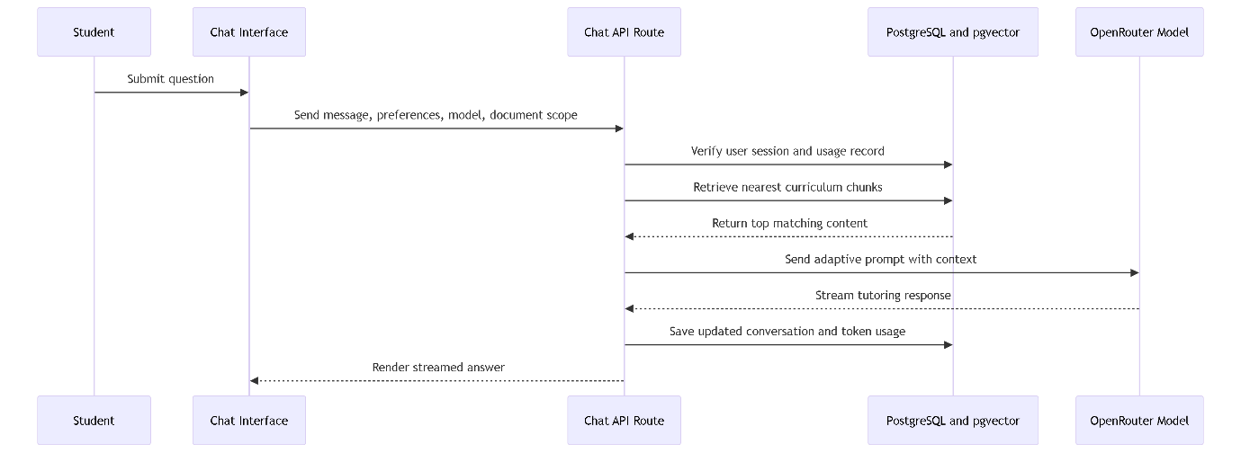
Figure 4.1: Runtime interaction sequence for an AI tutoring request
The adaptive behavior of the system was implemented pragmatically. Socratic mode and strict curriculum mode were exposed as user-controlled settings stored in local browser storage and transmitted to the chat endpoint. Experience level was inferred from the number of prior API calls and categorized into three bands: new, intermediate, and experienced. New users received more step-by-step, confidence-building explanations, while experienced users received denser and more technical responses. Although this was not a full mastery-tracking engine, it still created differentiated tutoring behavior using the available implementation scope.
The user interface further operationalized the system requirements. The dashboard acted as the entry point for learning activity, the library handled uploads and document review, the chat page enabled model choice and contextual tutoring, the analytics page summarized activity trends and usage counts, and the settings page supported profile updates, tutor preference toggles, and data deletion controls. This interface structure made the platform functionally complete as a personalized tutoring prototype rather than a single isolated chatbot screen.

4.3 SYSTEM VERIFICATION AND OPERATIONAL RESULTS
System verification was carried out through static code checks and direct inspection of the implemented features on 18 March 2026. Two verification commands were executed: npx tsc --noEmit and pnpm lint. The results are presented in Table 4.3.

Table 4.3: Verification outcomes for the implemented system on 06 March 2026
Verification activity | Outcome | Interpretation
TypeScript compilation (npx tsc --noEmit) | Passed | Core TypeScript definitions were internally consistent at the time of review
ESLint validation (pnpm lint) | Failed | The codebase still contained quality and standards violations requiring cleanup before final production hardening

Although the TypeScript compilation succeeded, the lint process reported 25 errors and 5 warnings. The reported issues fell into a small number of recurring categories:

Table 4.4: Summary of observed lint findings
Category of issue | Observed pattern | Practical implication
Explicit any usage | Several API and service files used untyped values | Reduces maintainability and type safety in critical logic
React purity warnings | A Date.now() call and a synchronous state update in an effect were flagged | Indicates render-time or lifecycle patterns that should be refined
Unescaped characters in JSX | Apostrophes in page content triggered formatting lint errors | Minor presentation issue with low functional risk
Unused variables | Some temporary variables were declared but not used | Low-risk cleanliness issue
Suppression comment quality | @ts-ignore was used where stricter suppression was preferred | Signals technical debt in type handling

These results showed that the application had reached a functional prototype state but had not yet completed its final quality-polishing phase. From a research perspective, this distinction is important: the platform successfully implemented its major educational workflow, but some engineering refinements remained necessary before the system could be described as fully production-ready.
Beyond static verification, the implemented modules demonstrated the following operational outcomes:
Table 4.5: Observable operational outcomes of the implemented prototype
Module | Observable outcome
Authentication | Users could access protected learning pages only after valid session checks
Document library | Users could upload PDF or TXT materials and see them listed as indexed files
Retrieval pipeline | Uploaded materials were chunked, embedded, and made available for context search
AI tutoring | Users could submit prompts, receive streamed responses, and continue prior conversations
Analytics | Users could view counts for questions asked, chat sessions, and indexed materials
Usage governance | Daily API call and monthly token usage thresholds were enforced through stored counters

The implementation also exposed several bounded design choices. The system supported PDF and TXT formats only, used top-five chunk retrieval, and depended on cloud-based model access through OpenRouter. In addition, the analytics page currently measured activity rather than true concept mastery. These design constraints were acceptable for the implemented scope, but they also marked clear boundaries around the present results.

4.4 DISCUSSION
The implemented system demonstrated that a personalized learning assistant could be operationalized as a curriculum-grounded web platform using modern LLM infrastructure and conventional software engineering tools. In relation to the study objective, the system succeeded in combining user authentication, educational document ingestion, semantic retrieval, adaptive tutoring prompts, and learner-facing dashboards into one coherent application. This placed the work in line with contemporary educational AI efforts that prioritize contextual assistance and scalable personalized support (El Hajji et al., 2025; LearnLM Team, 2025).
One important strength of the implementation was its explicit control of tutoring boundaries. Rather than allowing unrestricted responses, the system offered strict curriculum mode, source-aware prompting, and document-scoped retrieval. This was significant because Qadir and Mumtaz (2025) argued that AI tutors can distort trust when learners are not able to judge whether a system is truly grounded in reliable knowledge. By forcing the assistant to identify its source basis and optionally refuse unsupported questions, the implementation addressed this concern more directly than many generic chat interfaces.
Another strength was the practical treatment of personalization. The system did not yet include full cognitive diagnosis or mastery tracing, but it still individualized behavior through user preferences, stored activity, document selection, and conversation persistence. This resembles a lightweight implementation strategy in which pedagogical control is achieved through structured prompts and curated context rather than expensive model retraining, a direction also reflected in recent tutoring system reports (Wang et al., 2024; El Hajji et al., 2025).
However, the discussion must also recognize the limits of the current implementation. First, the adaptive learner model remained shallow because experience level was inferred from usage frequency rather than direct measures of understanding. Second, the project did not conduct a controlled user study, so it could not claim measurable learning gains comparable to those reported in experimental studies such as LearnLM Team (2025). Third, the verification results showed that while the prototype was functional, code-quality issues remained unresolved in the lint stage. Finally, the analytics module focused on activity indicators rather than validated learning outcomes.
Taken together, the results suggest that the system achieved its software implementation objective and established a credible foundation for a richer personalized tutoring platform. It aligned well with historical ITS principles of combining interface design, domain knowledge, tutoring logic, and learner modeling (Alkhatlan and Kalita, 2018), while adapting those principles to a present-day RAG and LLM workflow. At the same time, the implementation remained appropriately transparent about what had been completed, what had been simplified, and what still required empirical and technical refinement.

